《Diecutting & Stripping Machine BD-1050CS 》
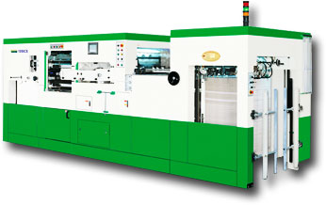
》Diecutting & Stripping Machine BD-1050CS >> Machinery Dimension 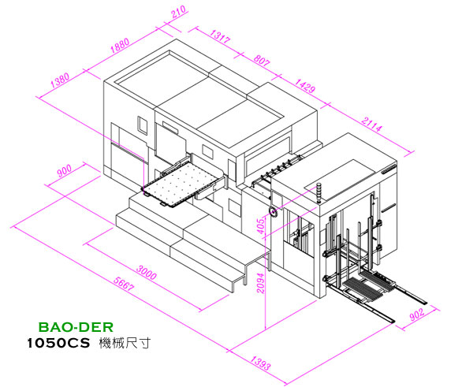

》Diecutting & Stripping Machine BD-1050C S>> Main Functions
- LCD serene dialogue window displays all kinds of information with recording and setting functions.
- Feeder can start to feed the first sheet of paper during high speed operation with fast speed and high accuracy.
- Adopts paper catch pincer that can ensure accuracy during high speed operation.
- Electronic control for slight left and right adjustment of feeder platform.
- Paper feed belt buffer structure. Thin paper can be die cut easily, quickly, and accurately.
- Lubrication oil constant temperature control that can solve the unevenness of cold shrinkage and heat expansion problem and can also protect machine from wear and tear.
- Electronic control digital display for die cut pressure. Operation is easy, clear and fast.
- Imported excellent hardness die cut steel plate. Solid and durable and is hard to be damaged.
- Die cut pressure protection device. Automatic shutdown when pressure is over 300 tons so as to ensure mechanical safety.
- Electronic control air pressure type for wedging of die frame. Speedy, light and easy operation.
- European main chain and vacuum pump. Durable and not easy to be damaged.
- Comes with non-stop feeding and delivery with automatic subsidiary paper collection rack. Speedy automatic conversion.

》Diecutting & Stripping Machine BD-1050CS
>> Machinery Specifications
max. paper size | 1050mm × 750mm
min. paper size | 400mm × 370mm
max. die cutting size | 1040mm × 730mm
max. cutting pressure | 300tons
min./max. thickness paper | 80g/㎡ ~ 1500g/㎡
max. corrugated board | 4mm
min. gripper margin | 8mm
max. machine speed | 7500 Sheets/hr
inner size of chase | 1145mm × 755mm
size of steel plate | 1080mm × 736mm
max. feeder overlap height （with platform〉 | 1250mm
max. delivery overlap height（with platform） | 1150mm
machine total power | 20kw
machine length | 7060mm
machine width | 3470mm
machine height | 2500mm
machine weight〈approx.〉 | 15.6 tons
★ Specifications are change without notice for improvement.

》Diecutting & Stripping Machine BD-1050CS
>> Machinery Introduction
Touch-screen
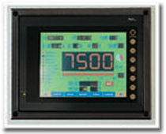
- Display all information during operation.
- Setting function for die cutting pressure/paper insert length indications etc.
Paper feeding divice
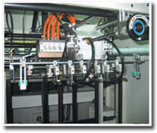
- Excellent and delicate feeder design that allows steady and accurate paper feeding
- Height and angle of one suction and two suctions can be adjusted individually
- Height and angle of first suction and second suctions can be adjusted individually.
- Outfitted with preparation paper accumulation platform to enhance production volume and performance.
- Outfitted with non-stop feeding speedy automatic conversion between main/ auxiliary paper rack.
Conveyance positioning structure
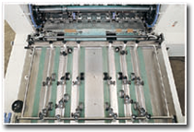
- Push/pull device for horizontal positioning.Conversion is easy and simple and facilitate sselection of paper.
- During operation the two sets or front positioning can arbitrarily adjust the tolerance of front and back/slanting.
- Double sheet device that can check whether there is double sheet feeding and it will shutdown to protect machine.
- Automatic shutdown device that can check for abnormal precision of paper feed front / horizontal positioning.
- Paper feed belt buffer device – to stabilize accuracy of thin paper.
Pressing unit
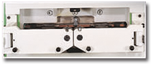
- US import pressure controller.Automatic shutdown when die cut pressure is over 300 tons in order to ensure mechanical safety.
- Electrical equipment digital control for die cut pressure adjustment.Can be displayed on the screen for recording and setting.
- Die frame adopts air pressure pinching.

Die cutting unit
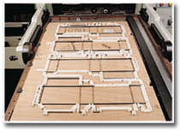
- Curve operation structure with heavy loading durability Stable pressure, high precision,wear and tear durability.
- Safety die cutting frame design, Easy installation and dismantling. Rotation die frame design that allows easy replacement of die cutters.
- Imported excellent hardness die cut steel sheet,durable and wear and tear resistance.
Stripping unit
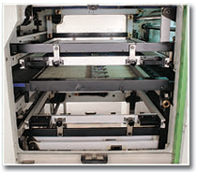
- Residue removal upper and lower push pin. Easy installation and dismantling. Adjustment is simple and quick.
- Upper structure can be elevated or lowered depending on requirement.
Paper margin disposal structure
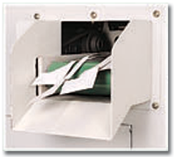
- Paper margin disposal discharge design is only available in model PD-1050CS.
Delivery unit
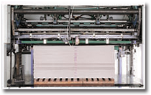
- Brush and lower/ side nozzle are utilized to stabilize effect of uniform paper collection.
- No-stop delivery for full paper during operation.
- To set up paper indicator insert device
- Can set total paper number and automatic shutdown function

寶德企業股份有限公司 Baoder Enterprise Co.,Ltd.
NO.178-7,Wen-cheng Rd. Taishan,Taishan,Taipei County,Taiwan
TEL：886-2-2900-5551~53 FAX：886-2-2900-8633

